Practical-5: Replication using Mangodb

**Date:-07/02/2025 Submission Date:- 14/02/2025**

Implement Replication

You are a database administrator for a company, and you need to set up a MongoDB replica set to ensure high availability and data redundancy. Perform the following tasks:

* Initialize a replica set with three nodes on different ports (27017, 27018, 27019).
* Check the status of the replica set.
* Add a new secondary node to the existing replica set.
* Simulate a failover scenario by stepping down the primary and observing the election of a new primary.
* Check replication status and read from a secondary node using readPreference

Step1: Create folders in c or d drive with name data

Then create sun folders name it as

1. Primary
2. Secondary1
3. Secondary2

Step 2: Open Windows PowerShell ISE and type the command

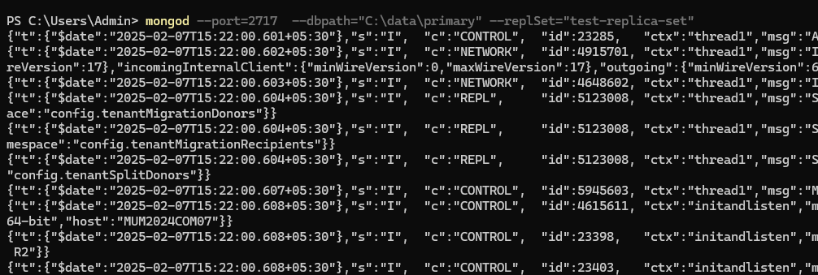

Open new shell and type the command

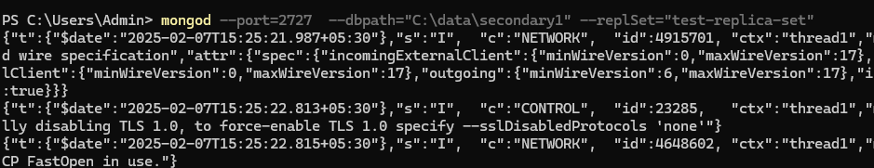

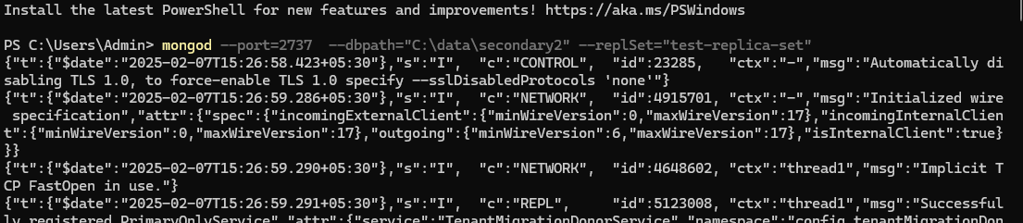

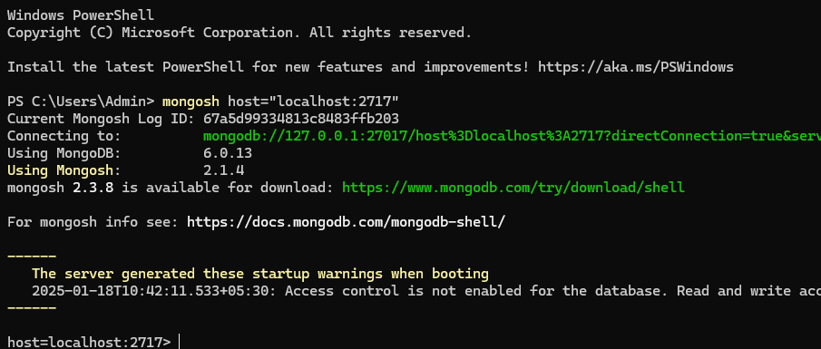

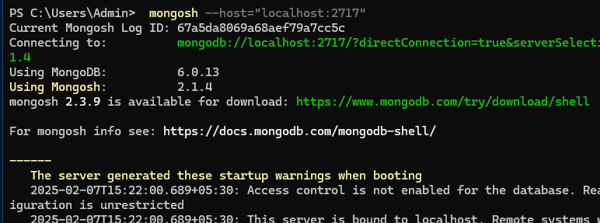

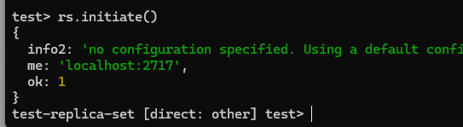

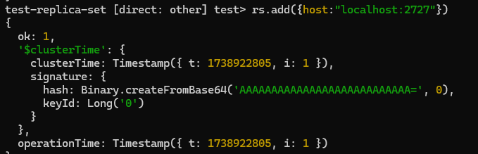

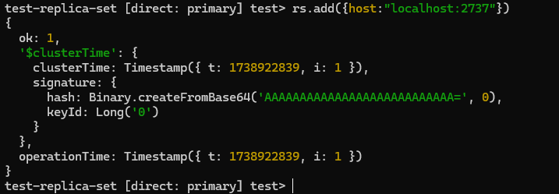

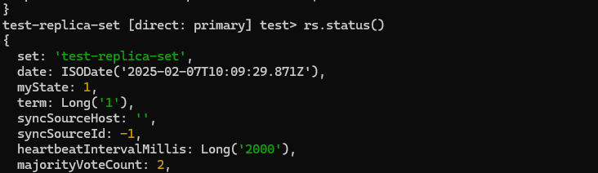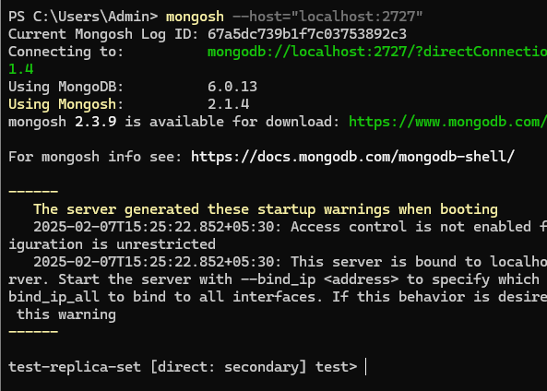

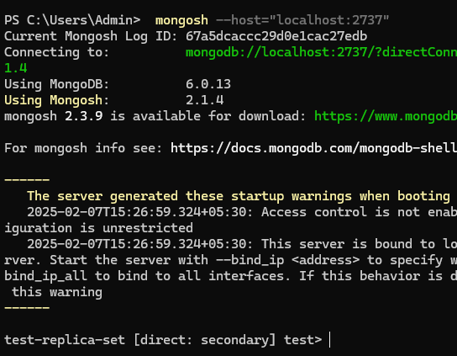

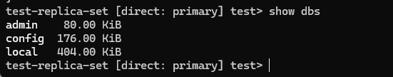

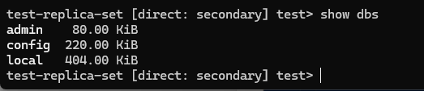

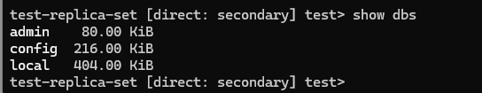

Step 3: Create database and do CRUD Operations:

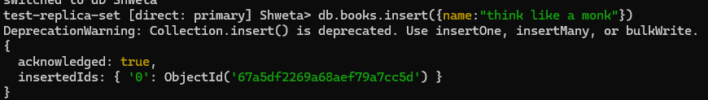

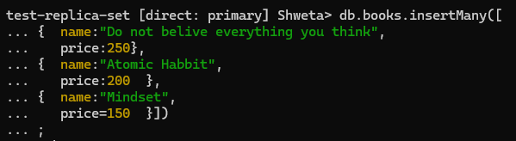

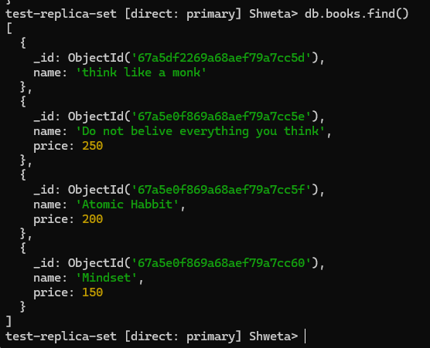

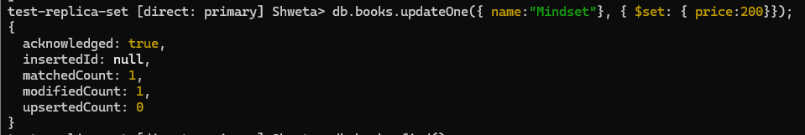

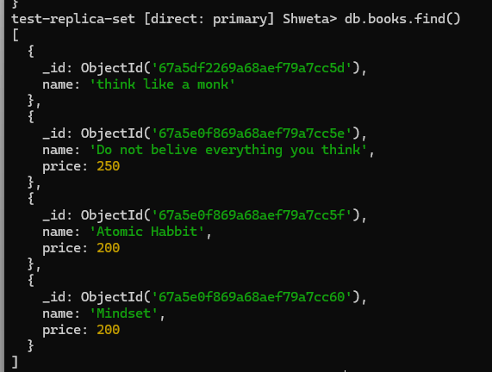



Check whether the replication has been done on Secondary folder



